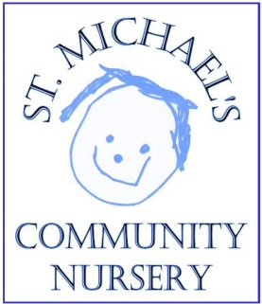 | Application Form  St. Michael's Community Nursery is a community nursery, and as such relies on parents and carers to support the management, fundraising, and the community events of our catchment area.
The Nursery is open to all children from when they are 2 until they are old enough to go to their first school. We are currently open Monday to Friday during term time. Standard sessions are from 9:15am to 12:15pm at Mickleham Village Hall plus optional Lunch Club until 1.15pm on Tuesdays and Wednesdays. Children may apply to attend for extended days (9.15a.m. to 2.45p.m.) on Monday's and Thursdays; priority for the extended days will be given to children who will be three years old before the September of their application year. We may increase our hours to meet the needs of the local community.

Child’s Name:
Child’s Date of Birth:
Parent(s) title & Name(s)
Address and postcode

Telephone No: |  | mobile
email
School attended by siblings
Please indicate which days you would like your child to attend (subject to availability):
Monday  Monday p.m. |  | Tuesday  Tuesday lunch |  | Wednesday  Wednesday lunch |  | Thursday  Thursday p.m. |  | Friday

Or if you have no preference please indicate how many days you would like…………………days.

We currently provide 15 fully funded hours for 3&4 years olds (from the term after a child’s 3rd birthday) and also offer places for FEET funded children. Some families are eligible for up to 30 fully funded hours. We do not currently offer these extended hours but are able to work with other providers to help eligible parents access 30 hours.

Please briefly indicate any special requests or requirements about religious observance, food, clothing, health or other matters which may be relevant to your child’s time at Nursery.
__________________________________________________________________________

Signed: __________________________ (Parent/Carer)

Please return this form to: St Michael’s Community Nursery, Village Hall, Dell Close, Mickleham, Surrey. RH5 6EE. Or email to stmichaelsnursery@btinternet.com.
A non-refundable fee of £30 will be charged to process your application (cheque payable to St. Michaels Community Nursery, or via BACS using your child’s name as a reference HSBC, sort code 40 19 22, acct number 31580108. For further information ring 01372 361021.
Finally ~ please let us know how you found out about St Michael's Community Nursery:

___________________________________________________________________________

For Nursery Use:
Date Form Received:

